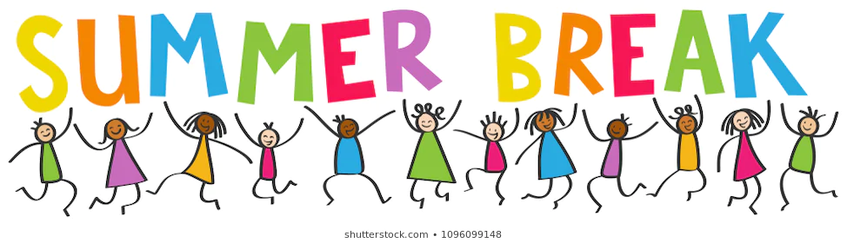
Hello SKS Parents,
I cannot believe the school year is over! To say that this year has been a whirlwind of experiences is an understatement. One thing is for sure, I have loved every single minute of being your kiddo’s Kindergarten teacher. They are my first Kindergarten class, so they hold a very special place in my heart.
Summer is a great time to relax and have fun in the sun! With that fun, it is also important for kiddos to keep up with their reading, writing and math. This does not need to be like homework, laborious, or intense. A couple minutes a day working on these subject areas will greatly help your child prepare for the beginning of 1st grade!
Research has shown that children who read and write a few minutes a day can make a measurable difference in their academics. Over the summer, I encourage your child to read and write, to you, with you, or by him/herself. This small step will ensure a smoother transition into 1st grade! As always, steer your child towards books they will enjoy but can also read with comfort and ease And, of course, any high frequency/site word work over the summer is also strongly encouraged. You can find these high frequency word lists by doing a simple google search of “kindergarten high frequency word list.”
The lessons that I have posted on my webpage will be archived so you are free to access them anytime during the summer! The supplemental websites we have been using throughout the year are available for student use over the summer as well as the instructional component of iReady, which will be available until August 7th. Please feel free to utilize these tools as you see fit!
Other tools that I have found useful over the summer while tutoring are: frequent visits to the library (if possible!), reading books from the summer booklist, practicing math facts on flashcards, ordering BrainQuest books from Amazon (an inexpensive and fun tool for kids to use at their own pace), and even investing in summer tutoring if that is something you and your child are interested in!
Again, thank you all for everything you do for your kiddos. It has been a pleasure working with you all this year- especially during this unprecedented time. You make our jobs easier by being invested in your child’s education and learning. Thank you and enjoy the summer!
Best,
Maria Garbach

