Hello SKS Parents,
I want to start this email by saying a huge thank you to all of you for all the support and understanding during this difficult and confusing time. Our main priority is your child and his/her education and I intend to fulfill those needs as best as I can via a remote learning experience. I know that this situation is less than ideal, but please know I am here to assist in any way! The next few weeks are going to be a learning experience for me as well so if there are any questions or comments that you need clarification on, please do not hesitate to email me (maria.garbach@dor.org).
If your child was not in school this past Friday, or if you need to pick up any of your student’s belongings, there will be a pickup from 9am-12pm tomorrow (Tuesday 3/17) at Saint Kateri.
My main goal over the next couple of weeks is to engage your kiddos in planned learning experiences that supports academic concepts that we have learned in the classroom. I will be posting assignments, activities, interactive website recommendations, book readings, instructional videos, etc. on my teacher webpage- http://mgarbach.saintkaterischool.org/ . Remote learning is going to look different for everyone’s schedules. I know there are going to be days were learning is going to be a little more difficult than others in terms of accessibility and time. This is very understandable so please don’t fret if your child does not get to a required assignment. This remote learning experience can be as involved as you want it to be! I do highly recommend that your kiddo keeps some sort of structure and participates in these online academic experiences so he or she is well prepared when the time comes to return to school.
Having this time with your kiddos may seem super overwhelming, but there are many fun things that you and your family can do to make this time a little brighter such as: family hikes, park walks, family game/movie night, scavenger hunts, fort making, book reading, crafts, Lego building, writing a letter to a family member or pen pal, cooking/baking together, daily family challenges and so much more! Pinterest is the best place to find cute ideas and activities! Below is a picture one of my colleagues forwarded to me that I thought was a really creative way to keep your kiddo on a daily routine (can be individually tailored to your day).
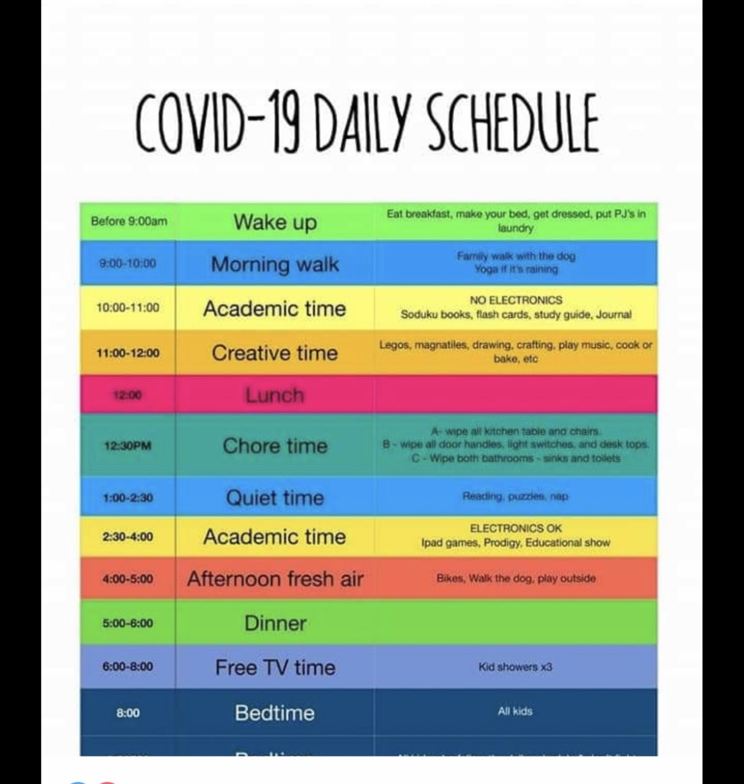
All instructional website login codes and directions went home with your child on Friday, March 13th. Please check their folder for these pieces of paper. Please note that I also have a copy of your kiddo’s logins and usernames if you should need it. Just email me and I will be happy to resend it to you.
While speaking with some of you today, there were some technical support issues that I wanted to clear up before remote learning begins to take place. Formal instruction will begin on Monday, March 23rd. However, please feel free to take advantage of this time to navigate the websites and get acquainted with the online programs. If there are immediate questions or concerns- this is a great time to email me so we can sort this out in a timely manner! Please note that iReady will be the main form of my assessment on student progress. Below are step by step instructions for logging into iReady, Splash Math, and ABC Mouse.
iReady: 1) Visit https://login.i-ready.com/ (copy and paste or click the link)
2) Click the “K-1 Card Login” (the sign the little orange alien is holding)
3) Enter our class number 554210 (also on the laminated card that was sent home on Friday)
4) Find your child’s name and click on their avatar
5) Enter your child’s picture code (also on the laminated card that has the class number)
6) Choose a subject (Reading or Math)
7) Begin Lesson!
**If you are using an Apple device, iReady will not work until you download the free app!** I will be attaching pictures of this in the email. Please let me know if there are any further issues so I can sort them out.
Splash Math: 1) Visit https://www.splashlearn.com/
2) Click Login in the upper right-hand corner
3) **CHOOSE CLASS***
4) Enter class code QNWGSI (on the slip of paper that went home on Friday labeled “Splash Learn”)
5) Click on you child’s name
6) Click on your child’s picture password (Also on the slip of paper that went home on Friday labeled “Splash Learn”)
7) Click the orange “start” button to begin or you can click on the orange “go to curriculum” button to get more lessons to choose from!
ABCMouse: * This website can run slow at times! **This website works best on the Internet Explorer and the Firefox browsers! If you do not have either browser, you can easily download it by googling “internet explorer download” or “firefox browser download.”
- Open Internet Explorer or FireFox browser
- Visit https://www.abcmouse.com/
- Click on Log In
- Enter username- Melinda.viscardi@dor.org and password- kindergarten2020
- Click on Student Login (to the left)
- Click on your child’s name
- Put in your child’s picture password (went home on a slip of paper on Friday)
- Begin exploring and learning!
Also attached to this email are other websites (some with user codes) that I will be utilizing for instruction and you can have your kiddo explore at any time!
Please contact me at any point if you have any questions, comments or concerns. I am here for you and your child and we will get through this transitional time together. If a phone conversation is better for you, please let me know and we can get something set up! Also, at any point, if you find that you are in need of internet access, a computer device, food and or supplies, please do not hesitate to reach out to me! Also, if you and your kiddo want to send me pictures/videos of their work I would be more than happy to receive those via my email! I already miss their precious faces.
I look forward to this new learning experience with you and your kiddo! My thoughts and prayers are with all of you at this time. Please give lots of hugs to my Kindergarten friends! #keepcalmandwashyourhands
Best,
Maria Garbach

