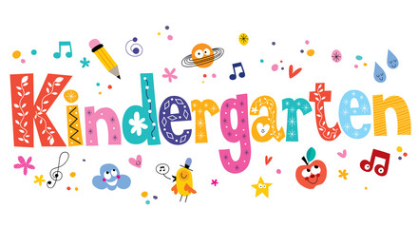
In This Classroom…
- We Respect Others and Ourselves
We use kind words and actions
- We Have Listening Bodies
We listen and follow directions quickly and quietly
- We Work As A Team
We are our BEST selves every day for our class community
- We are Responsible
We take ownership for our actions and apologize/forgive when need be
- We Follow the Golden Rule
We treat other how we would want to be treated

Our Classroom Expectations
- We always try our best
- We have listening ear and looking eyes
- We raise our hand
- We keep our hands and our feet to ourselves
- We lineup and walk quietly in the hall
- We follow directions quickly and quietly
- We know when to go from silly mode to work mode
- We love ourselves and others
- We use kind words
- WE TREAT OTHERS HOW WE WOULD LIKE TO BE TREATED!
What happens If I Choose to Break a Rule?
1St Offense: Verbal Warning
2nd Offense (on the behavior ladder): Moves down from Green (Ready to Learn) to Yellow (Slow Down)- child is talked to individually to reflect on behavior
3rd Offense: Moves down from Yellow to Orange (Think About It)- 5 minutes off recess to discuss “My Action Plan”
4th Offense: Moves Down from Orange to Red (Oh No! Stop!)- Parents are called and meeting is set up
5th Offense or Severe Disruption: Meeting is set up with Principal

Students ALWAYS start on Green (Ready to Learn) each day and are able to move up the “Behavior Ladder” (Blue- Good Work, Purple- Great Effort, Pink- Outstanding Student) as the day progresses. At the end of the week, students who are on or above “Green” get a treat!
Students who choose to break a rule and go down the “Behavior Ladder” are ALWAYS able to improve behavior to move back up!
*Please Note: At the end of the day, each student will go home with their weekly behavior chart for you to view NIGHTLY. At the end of the week, this needs to be signed by parent/guardian and returned to school the following Monday.
Rewards
*Praise *Positive Notes/Calls/Emails Home *Extra Recess *No Shoes Day *Sit Next to a Buddy *Friday Free Time *Homework Pass *Treasure Box Treat *The Joy of Learning Everyday

My Action Plan

- What is the problem?

- What is causing the problem?

- What is my plan to improve or solve the problem?

__________________________________
Student Signature
_________________
Date

*Resource from The First Days of School by Harry K. Wong and Rosemary T. Wong
STUDENTS: I have read (with a parent) the Class Community Plan and understand it. I will honor it while in Miss Garbach’s Room.

Signature _____________________________________ Date ____________

PARENTS: I have read the Class Community Plan with my child and we have discusses it. I understand it and will support it.

Signature _____________________________________ Date_____________

TEACHER: I will be fair and consistent in administering the Plan for my students.

Signature _________________Miss Garbach_______________

****IMPORTANT****
PLEASE KEEP THIS SHEET IN STUDENT FOLDER AT ALL TIMES.
THANK YOU!

